Embargoed until: 00.01am Monday 10th November 2025
A footballer. A TV presenter. 8 million children. One powerful message: Let’s bring an end to bullying!
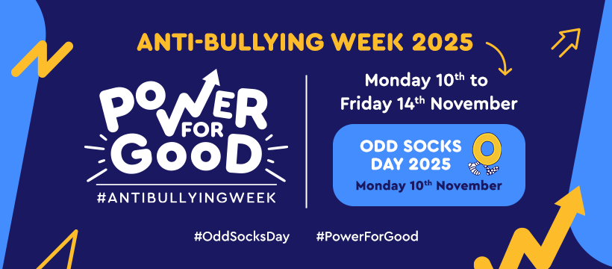
Millions of children unite to use their Power for Good
This November, more than 8 million children and young people across the UK are taking part in Anti-Bullying Week 2025, running from 10 to 14 November. Coordinated by the Anti-Bullying Alliance (ABA), the campaign is supported by patrons Andy and the Odd Socks, and Rúben Dias, Manchester City and Portugal footballer.
This year’s theme, Power for Good, celebrates the ability we all have to stand up to bullying, spread kindness, and create safer environments for every child. Anti-Bullying Week begins with Odd Socks Day on Monday 10 November – a fun, inclusive day, led by the hugely popular Children’s TV Stars, Andy and the Odd Socks, where children and adults wear odd socks to celebrate what makes us all unique.
A national call for government action
The Anti-Bullying Alliance Advisory Group, made up of leading organisations working with children across the UK, is calling on government to take stronger national action. They are urging ministers to ensure that all schools and those working with young people receive the skills, training, and support they need to:
- Identify bullying early
- Respond effectively and sensitively
- Build inclusive cultures that prevent bullying before it starts, especially those most at risk.
The group emphasises that bullying prevention must be seen as a core part of safeguarding children and an essential part of promoting wellbeing and equal opportunities.
A week of celebration and action
Anti-Bullying Week will include:
- Odd Socks Day, encouraging individuality and kindness with a new toe tapping song from Andy and the Odd Socks
- A Parliamentary event on Wednesday 12 November bringing together MPs, Lords, ABA patrons, and young people to discuss solutions.
- The Anti-Bullying School Staff Awards, honouring staff who go above and beyond to support children.
- Free school resources for schools to embed anti-bullying messages into school life.
- Campaign activity in thousands of schools, youth settings, and homes nationwide, including events led by Young ABA, the Alliance’s youth activist group.
Bullying still affects more than one in five children every year
Despite progress, more than one in five children and young people experience bullying each year. The impact can be devastating, affecting their mental health, confidence, and ability to thrive at school, with the effects often lasting into adulthood.
Patrons Rúben Dias and Andy Day join the movement
Rúben Dias, Patron of the Anti-Bullying Alliance, said:
“Growing up I saw abuse, exclusion and damage being caused. That is why being part of Anti-Bullying week matters to me. I want young people to stand up against it and help each other to be better.”
Andy Day, Andy and the Odd Socks, said:
“Music and laughter can open doors to real conversations. By having fun, like Odd Socks Day, we can show that our differences are our gifts, not something to hide. For me, Anti-Bullying Week is more than a campaign, it’s a reminder that every child deserves to be seen, heard and safe. When I visit schools, I’m always moved by the way children come together to support each other. You can really see the Power for Good young people have when they stand up for one another.”
Minister for Early Education, Olivia Bailey said:
“Bullying and discrimination have absolutely no place in our society, whether in the classroom, outside of school or online.
“Anti-Bullying Week is a vital reminder that every one of us has the power to make a difference and captures what education is all about, empowering young people to speak up, show kindness, and create safe, inclusive communities.
“We’re doing a lot to support young people in this space, including providing mental health support in every school and delivering a comprehensive programme of behaviour and mental health support.”
Co-Chairs of the Anti-Bullying Alliance Advisory Group, Jennifer Moses and Will Gardner said:
“With bullying still affecting more than one in five children each year, now is the moment for decisive national investment in prevention, training and support. Our call is simple: equip every adult who works with children with the knowledge, confidence and resources to understand their role in preventing and responding to bullying face to face and online, contribute to safer environments where children can thrive. That is Power for Good in practice.”
Yassmeen, 16, Young ABA member (who have helped us developed the campaign), said:
“I joined the Young ABA because I’ve always wanted to help others, being able to aid in such a meaningful cause is a huge privilege as someone who’s been on the receiving end.”
Young ABA Member, aged 14, (who have helped us develop the campaign) said:
“I have watched as multiple people have been bullied repeatedly and decided it was about time i did something about it”
Martha Boateng, Director of the Anti-Bullying Alliance, said:
“Bullying does not fade away if we ignore it, it reverberates through a child’s confidence, health and future. This Anti-Bullying Week, we must turn awareness into action. Every school, youth worker and governor should have the training and tools to spot bullying early, respond effectively and build a culture where kindness is the norm.”
Notes to editors
- Anti-Bullying Week 2025 takes place from 10 to 14 November with the theme Power for Good.
- The campaign in England, Wales and Northern Ireland is coordinated by the Anti-Bullying Alliance, based at the National Children’s Bureau.
- Odd Socks Day, on Monday 10 November, is supported by Andy and the Odd Socks.
- The Anti-Bullying School Staff Awards celebrate outstanding individuals in schools who make a positive difference in children’s lives.
- More information and campaign materials can be found at: www.anti-bullyingalliance.org.uk/antibullyingweek
Press enquiries
Email: media@ncb.org.uk / Phone: 07721 097 033
Interviewee availability
- We have members of staff available for interviews
- Video available of Ruben Dias and Andy Day talking about why Anti-Bullying Week is so important to them.
- Our School Staff Award Winners would be available for interview (please contact media@ncb.org.uk to find out more)
Case study quotes from Young ABA
- “I’ve always been aware of my different appearance compared to others around me. I’ve felt insecure and out of place before because of comments made towards me. Being able to talk to people I trust made me feel more confident and accepting of my differences.” – Young ABA member (16)
- “Growing up as a girl of colour I thought that I needed to keep my problems to myself, but now, I've come to realise that it's never a good idea to bottle up your emotions. There is always somebody you can talk to.” – Young ABA member (14)
- “For young people to feel safe and included adults need to be good role models” – Young ABA member
Images: High-res images available for media use
Social media: Campaign social media toolkit / Hashtags: #AntiBullyingWeek #PowerForGood #OddSocksDay
Statistics and information about bullying
- Almost 1 in four children experience frequently experiencing bullying behaviours in the UK.
- Pupils with SEND and those in receipt of Free School Meals are at heightened risk.
- Bullying causes children to miss school, do less well at school and the ramifications can last long into adulthood.
- The Anti-Bullying Alliance has three key policy recommendations for government:
  - Initial Teacher Training should include mandatory training about how to prevent and respond to bullying.
  - Each school should be required to have a lead for anti-bullying
  - Schools in England and Wales should have a duty to record levels of bullying as there currently is in Northern Ireland.
Anti-Bullying Tips for parents and carers
- Create space for calm conversation: Find a quiet time to talk and listen without interrupting or judging
- Ask open questions: Use phrases like “Can you tell me more about what’s been happening?” rather than yes/no questions.
- Notice changes: Look out for signs such as avoiding school, mood swings, or missing belongings, which may suggest bullying.
- If they’re being bullied: Remind them it’s not their fault and that you’ll work together to make things better.
- If they’ve seen bullying: Talk about the importance of kindness and safely supporting others, like telling an adult or offering friendship.
- If they’ve been involved in bullying: Stay calm, help them understand how their behaviour affects others, and focus on helping them put things right.
- Work with the school: Contact your child’s school and share concerns early.
- Model empathy and respect: Show through your own actions how to treat others kindly, even when upset.
About the Anti-Bullying Alliance
The Anti-Bullying Alliance (ABA) is a coalition of organisations and individuals working together to stop bullying and create safe environments for children and young people. Based at the National Children’s Bureau, the Alliance brings together over 150 member organisations to influence policy, share best practice, and support schools and communities across the UK to reduce bullying.
ABA’s Advisory Group consists of the National Children’s Bureau, Childnet, Kidscape, The Diana Award, NSPCC, London Borough of Wandsworth, Nottingham Trent University, Stranmillis University, BulliesOut, NASUWT, UK Safer Internet Centre.
About the National Children’s Bureau
For more than 60 years, the National Children’s Bureau has championed the rights and amplified the voice of children and young people in the UK. We interrogate policy and uncover evidence, blending in lived and learnt experience to shape future legislation and develop more effective ways of supporting children and families. Bringing people and organisations together is fundamental to how we improve the systems that babies, children, young people and their families rely on to thrive. We push boundaries, even looking beyond childhood itself to consider transitions into adulthood and the impact of childhood issues on an entire lifespan. We are united for better childhoods and brighter futures.

https://anti-bullyingalliance.org.uk/sites/default/files/uploads/attachments/Pupil%20bullying%20wellbeing%20and%20school%20experiences%20in%20schools%20in%20England%202024.pdf

