Media release
Embargoed until: 00:01am Monday 13th November 2023
Bullying or banter? It’s time to speak-up and ‘make a noise’ if someone crosses the line
- Over 1 in four teachers say that face-to-face banter in schools is a serious problem in their schools, yet 84% receive no training on how to deal with banter.
- Almost 1 in 4 children (23%) said they are being frequently bullied face-to-face, with the situation even worse for those with special educational needs and disabilities (29%), or those from poorer families (28%).
- ‘Make a Noise’ is the theme for Anti-Bullying Week 2023 taking place from 13 to 17 November 2023, encouraging children and adults to not stay silent about bullying.
- Odd Socks Day marks the start of Anti-Bullying Week on Monday 13 November. It is supported by CBeebies presenter & ABA patron Andy Day and his band 'Andy and the Odd Socks'. To take part, wear odd socks to your school, at work, or at home.
- Anti-Bullying Week is coordinated in England, Wales and Northern Ireland by the Anti-Bullying Alliance and is expected to reach over three-quarters of schools and over 7.5 million children.

A Nottingham Trent University survey of nearly 900 UK teachers co-created with the Anti-Bullying Alliance, suggests that over a quarter of them (26%) think banter is a serious problem within their schools, with even more (37%) thinking its effects online are serious.
62% of the teachers agreed that there is a fine and subjective line of acceptability between banter and bullying.
Knowing when banter crosses the line into bullying is a challenge for teachers, as the overwhelming majority (84%) receive no training on the issue, and 64% say they have no school policy for dealing with banter to fall back on.
Campaigners are concerned that this is opening the door for bullying to proliferate.
In separate Anti-Bullying Alliance research of nearly 65,000 pupils in England, researchers at Goldsmiths, University of London, found that almost 1 in 4 children (23%) said they were being frequently bullied face-to-face, with the situation even worse for those with special educational needs and disabilities (29%), or those from poorer families (28%). One in twenty children (5%) report being bullied frequently online. 6% of children say that they often bully others.
As part of this year’s Anti-Bullying Week campaign, the Anti-Bullying Alliance is urging everyone to think about what we mean by banter, the role banter plays in bullying and how we can tackle it.
Campaigners insist that too often we are silent when we see bullying take place, silent about the hurt bullying causes, and silent when we hear bullying dismissed as ‘just banter’.
It doesn't have to be this way. This is why ‘Make A Noise About Bullying’ has been chosen as the theme of Anti-Bullying Week from 13 to 17 November, urging people to speak to someone they trust if they are being bullied, and not to be a silent bystander if they see it happening to someone else.
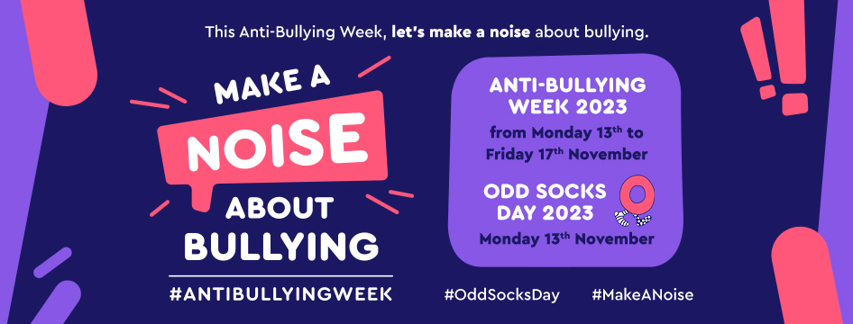
Martha Evans, Director of the Anti-Bullying Alliance, said:
"Banter is a fun part of communication, but too often bullying behaviours are dismissed as ‘just banter’. Recognising the fine line between banter and bullying is crucial for the development and emotional well-being of our children. We want to see schools having these conversations with pupils this Anti-Bullying Week. We must empower educators with the confidence to support children, fostering an environment where every child's voice is heard and respected and we hope Anti-Bullying Week 2023: Make A Noise can help achieve this."
Odd Socks Day takes place on the first day of Anti-Bullying Week. There’s a serious message behind the fun: let’s pull on odd socks to show we’re ALL unique and different, and let’s be kind to each other and respect each other’s individuality.
Children’s TV star, Andy Day and his band Andy and the Odd Socks, are supporting the campaign again in 2023 and have released a new video and song with young people ‘Make A Noise’.
Andy Day said:
“I'm absolutely thrilled to be part of Odd Socks Day again this year – a seriously awesome way to remind everyone that it's cool to be different and stand up against bullying! Let's rock our odd socks and make a noise about bullying!"
David Johnston, Minister for Children, Families and Wellbeing, said:
“Bullying is never acceptable, which is why this government is committed to working with schools to create good behaviour cultures and to improve approaches to tackling bullying. We’ve created behaviour hubs across the country, included teaching respect and inclusivity as part of the RHSE curriculum and provided more than £3m of funding to anti-bullying organisations to support their vital work.”
Professor Lucy Betts, Nottingham Trent University, said:
“Our research has shown that there is a fine and subjective line between banter and bullying. In most cases, sharing jokes and banter with friends can be fun and can help strengthen these friendships. However, when the banter stops being funny or when it crosses the line of acceptability, these behaviours may become bullying. Therefore, we are delighted to have had the opportunity to work with the Anti-Bullying Alliance to develop resources for Anti-Bullying Week.”
Get involved!
It’s easy to get involved on social media using #AntiBullyingWeek and #MakeANoise on Instagram, TikTok, Facebook and X (Twitter).
- Anti-Bullying Week and Odd Socks Day reaches millions of children, and their families so look out for #AntiBullyingWeek trending across your social media feeds.
- We are expecting lots of celebrity support for the campaign. In past years, stellar influencers including Victoria Beckham, Prime Minister Rishi Sunak, Craig David, and Ant and Dec have all shown their support for Anti-Bullying Week.
- You can find a collection of quotes from young people and our supporters here.
*** END ***
Notes to editors
About the surveys
- A sample of nearly 900 teachers was recruited through Prolific. Participants were teachers based in the UK and they were surveyed from May to June 2023. The results were analysed by researchers at Nottingham Trent University.
- A questionnaire of almost 65 thousand pupils across England was taken from November 2022 to February 2023 as part of our United Against Bullying programme. Schools provided pupils with access to the questionnaire at the start of the programme to provide us with baseline data. The questionnaire results provide us with a picture of children and young people’s experiences of bullying in England, their experiences at school and their wellbeing. The data was analysed by Goldsmiths, University of London.
About Anti-Bullying Week
Anti-Bullying Week is organised by:
- The Anti-Bullying Alliance in England, Northern Ireland and Wales
- respectme, Scotland’s anti-bullying agency

About the Anti-Bullying Alliance
Anti-Bullying Week is coordinated in England, Wales, and Northern Ireland by the Anti-Bullying Alliance. We are a unique coalition of organisations and individuals, working together to achieve our vision to stop bullying and create safer environments in which children and young people can live, grow, play and learn. We are part of the National Children’s Bureau. We are united against bullying.
For more information visit: www.anti-bullyingalliance.org.uk
About the National Children’s Bureau
For 60 years, the National Children’s Bureau has worked to champion the rights of children and young people in the UK. We interrogate policy and uncover evidence to shape future legislation and develop more effective ways of supporting children and families. As a leading children’s charity, we take the voices of children to the heart of Government, bringing people and organisations together to drive change in society and deliver a better childhood for the UK. We are united for a better childhood.
For more information visit www.ncb.org.uk

